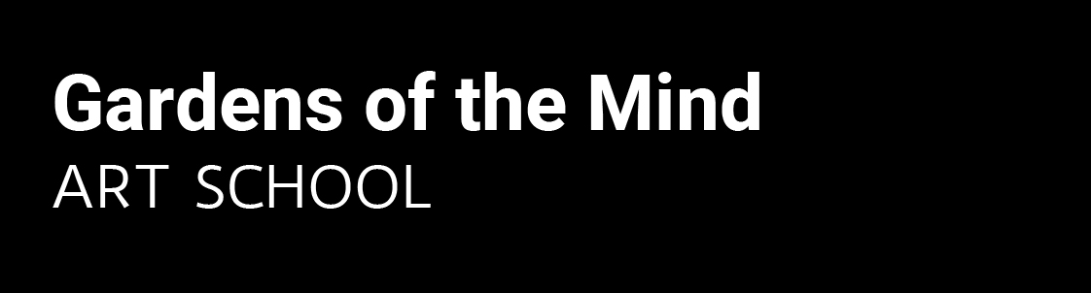

TERMS AND CONDITIONS OF ENROLMENT
Please read the following carefully before completing the enrolment form:
Enrolment
Please complete the enrolment form and forward to:
Gardens of the Mind
8/287 Norton St Leichhardt 2040
Or
Email: gotm_maddie@yahoo.com.au

Course Fees
Course fees are $145 per term for an 8 week term. Fees are inclusive of GST and tax receipts will be provided on receipt of payment.
10% discount on fees when siblings are enrolled.
Fees must be paid in full before commencement of class.

Cancellation and Refunds
'Gardens of the Mind' has the right to amend any course or schedule and to cancel a course due to insufficient numbers. If this is the case, a full refund will be arranged.
Fees are non-refundable.
Refunds will not apply to missed classes.

Absenteeism
If a student misses a class, the student will not be entitled to a ‘make-up’ class or discount.

Art Materials
All art materials are supplied for children’s art classes. Parents need to provide a paint shirt.

Student Conduct
All students are expected to respect other students, their teacher, all artworks and property.
Children exhibiting inappropriate or disruptive behaviors may be removed from the class. Cleaning of the learning area is a shared responsibility.

Punctuality
Students are requested to be punctual for class. Students’ attendance will be registered at the beginning of class and signed out at the end of class by their parent/guardian.

Occupational Health and Safety
Parents/guardians are requested to notify Gardens of the Mind of existing medical conditions, allergies or disabilities that may affect their child’s performance in class

Covid-19 Safety Plan
Students and parents must follow Gardens of the Mind Covid-19 Safety Plan, regarding hygiene, social distance and recording attendance. Our safety plan can be found on our website: https://www.gotm.com.au

Photography
Photographic images will be sometimes be taken of students’ artwork and their participation in class (no headshots). These images will be used for advertising, brochures and promotion of ‘Gardens of the Mind’. These photos will never be sold and will only be used by ‘Gardens of the Mind’. As a condition of enrolment your consent is implied. If any parent does not consent to this then please notify us in writing.

Privacy
Gardens of the Mind will occasionally send mail and email to parents for marketing purposes. If you wish not to be notified then email us and your contact details will be removed from our mailing list.
Gardens of the Mind is committed to respecting your privacy. We will collect personal information that lets us know the specifics of who you are and your personal details as you have provided to us. We will not disclose your information to any other group or organisation for any purpose. We will only use the personal information you have provided to us for the purpose for which you provided it. We aim to make sure that the information we hold is accurate, complete and up to date. If your personal details change, we request that you contact us, so that we can update the information we hold about you.

Please note "St James Catholic Primary and SCS do not accept responsibility for any breach of security by external providers".

Duty of Care
As this class is held outside school hours, students are under the care of Gardens of the Mind during class time. The administration of St James Primary School has requested that you please sign the following statement

As this session is out of school hours and run independently, please sign below stating that you are aware that Gardens of the Mind are responsible for the care of your child during the lesson, not the school.
Signature:
Date:

I hereby indemnify Gardens of the Mind against responsibility for accident, loss or injury suffered by my child during the course of classes
Signature:
Date:

